2026 Baseball and Softball Picture Day Schedule
Saturday, May 16, 2026
On Saturday, May 16, photographs will be taken on the lower fields. The event is rain or shine on the area between fields 5 and 8. Please plan to arrive at least 10 minutes prior to your scheduled session time.
Saturday morning scheduled time sessions are listed below by league and coach
All players and coaches on a sponsored team are required to attend for the team picture in full uniform regardless if you order any packages
Our photographer, AG Photography, only accepts pre-orders through their website. It is imperative to have the order forms completed prior to your scheduled photograph session. If you have concerns and/or questions, please contact AG Photography at customerservice@ag-photography.com.
All packages are to be pre-ordered at Fox Rok Athletic Association | AG Photography Inc –
- If the above link is not active, right click on the link and select “open hyperlink”
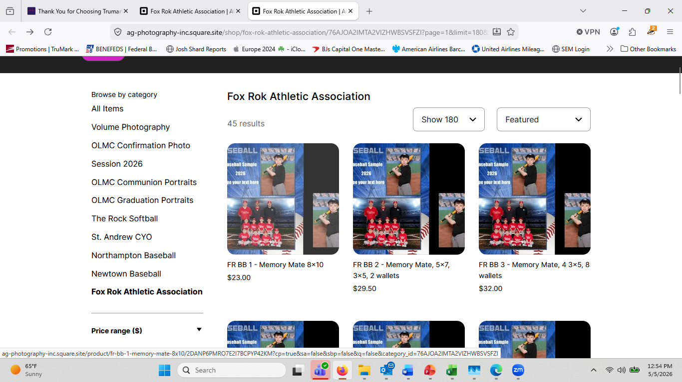
- Select your package(s)
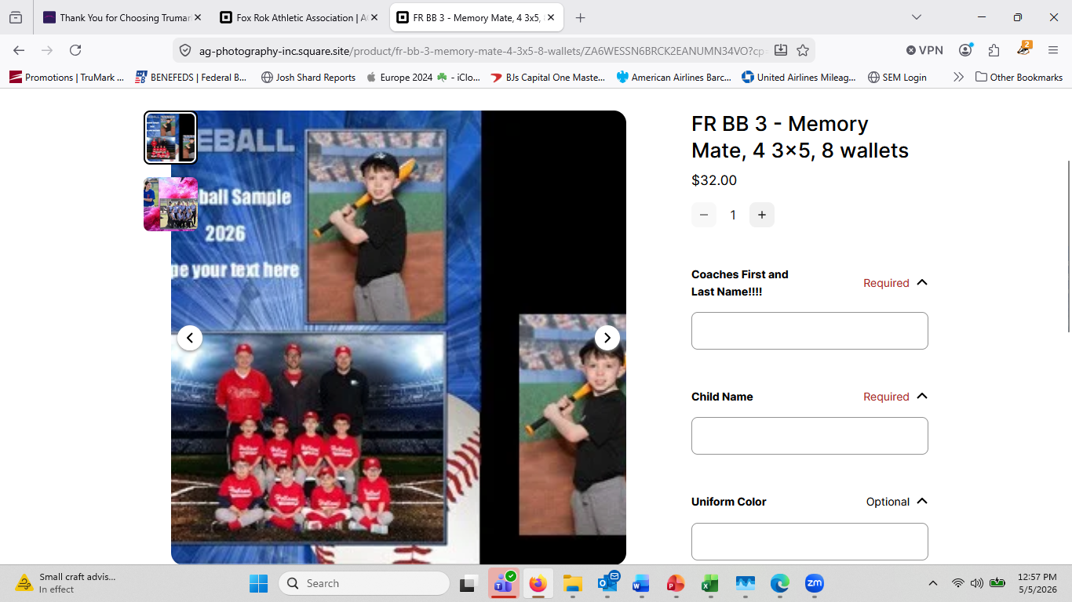
- Input
  - Coaches 1st and Last Name
  - Players 1st and Last Name
  - Team uniform color

- Click “add to cart”
- Continue to cart
- Review Order
- Click “continue to pay”
- Add payment information
- Click “Place Order”
Please be aware, all orders will say “Pickup at AG Studio * Photography 108 N Main St Ste 203 Doylestown, PA 18901-3718 US”.
This does not mean you have to pick them up at this location. All pictures will be delivered to Fox Rok AA and then distributed to coaches to hand out prior to the last game of the season
If you have concerns and/or questions, please contact AG Photography at customerservice@ag-photography.com.

2026 T- Ball Coaches
Pix Time Team
8:25 McCorry
8:30 Pachell
8:35 Matkowski
8:40 Grimaldi
9:10 Malseed
9:15 Wallace
9:20 Ralston
9:25 Sticco
10:30 McKeon
10:35 Popowicz

2026 Coach Pitch Coaches
Pix Time Team
8:45 Donovan
8:50 Keenan
9:40 Pfeffer
9:45 Gant
10:40 Hampson
10:45 Grimaldi

2026 Machine Pitch Coaches - Boys
Pix Time Team
8:05 Matthews
8:10 McKeon
10:05 Vescio
10:10 Eder
2026 In-House "Home League" Coaches - Boys

Pix Time Team
8:15 Mullane
8:20 Williams
10:50 Boggs
10:55 Stone
11:00 Montvydas
11:05 Pangborn

2026 Girls Softball Travel
Pix Time Team
9:30 Moody – 8U
9:35 Michel – 8U
10:15 Erat – 10U

2026 Boys Baseball Travel Coaches
Pix Time Team
8:55 Eck – 9U
9:50 Groves/Beck – 8U
10:00 Nolan – 10U

